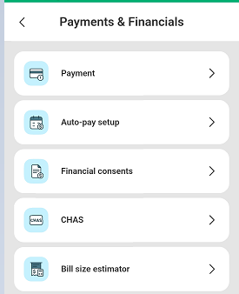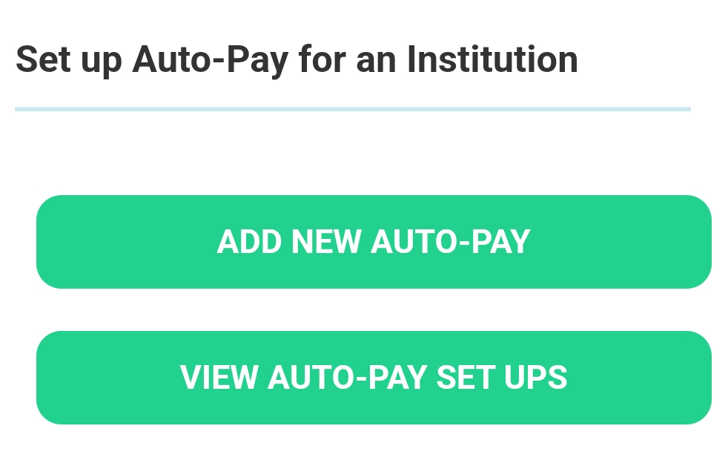
  - Auto-Pay Steps Guide for Expired/Termination of Payment Arrangement
- As the Payer, you can View and Edit your Auto-pay set-ups and make changes easily.

Go to HealthHub App
Navigate to the Payments & Financials page
and Select Auto-pay setup.

- Select the institution of your choice.
(National University Hospital / Jurong Health Campus)

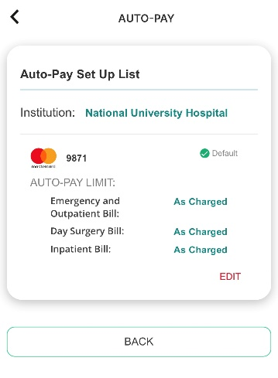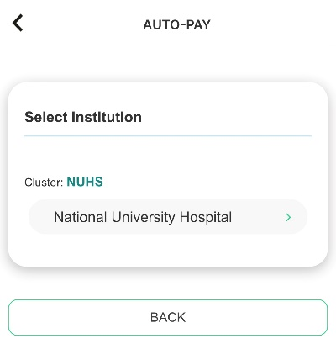
- Click on the EDIT button

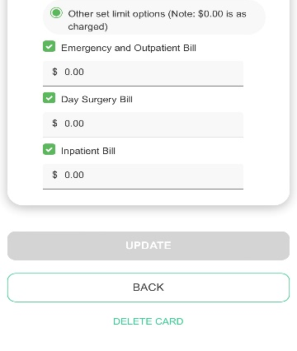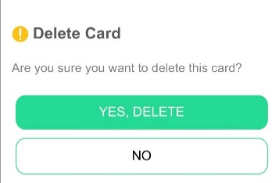
- Once you had deleted your current credit card, you may refer to our steps-to-steps guide on how to register a new Auto-pay with credit card.

- Click on the DELETE button

After confirming your desired set-up, please input your Card details into the Secured Payment Gateway and perform the verification through your card issuer.
Congratulations!
You have successfully set-up your Auto-pay Payment Arrangement.

